Progressive Report

Dingming

1. Background

The situations are clarified after the last discussion:

1. **Beat>up day1>retrace below day1>rebound over day 1**
2. **Beat>up day1>retrace below day1>always below day1**
3. **Beat>up day1>always up day 1**
4. **Beat>down day1**

图示

AI 生成的内容可能不正确。

A figure for quick catching up

**Key metrics:**

**Retrace date: The day when price retrace to day1**

**Trough date: The day when price drop to the minimum**

**Trough loss: how much the price loss on tough date**

**Peak date: After the trough, there will be a rebound and the day that the price reaches peak.**

**Peak gain: How much the price gain on peak date**

**Full-time peak: the highest pick before the next earning**

**Peak – Trough: how long it takes to be peak after a trough**

1. Data

I set the model as the following parameters:

1. Observe **20** days after earnings
2. Earnings over **10%** beat and over **10%** miss are calculated
3. **Semiconductor**, **59** stocks in total, U.S(**19**), EU(**13**), Asia Pacific Developed(13), Asia Pacifica Merging(**14**), All selected stocks are among the top-ranked by market capitalization.
4. Results

**Key Takeaways:**

1. Situation 1 has the largest quantity, about 59.6% of up day 1 situations.
2. Trough dates of 2, 3, 4, 5 are the most frequent in trough date distribution
3. For situation 1, the peak dates are more likely to be 18,19 , 20. However, only 20% of the peaks are not restrained by the window size.
4. Trough loss mainly lies in 0% to -2%, then -2% to -4%, while Peak gain is 0-2% and 6-8%

**Distribution of the four situations**

The distribution of the four situations is shown in the below figures:

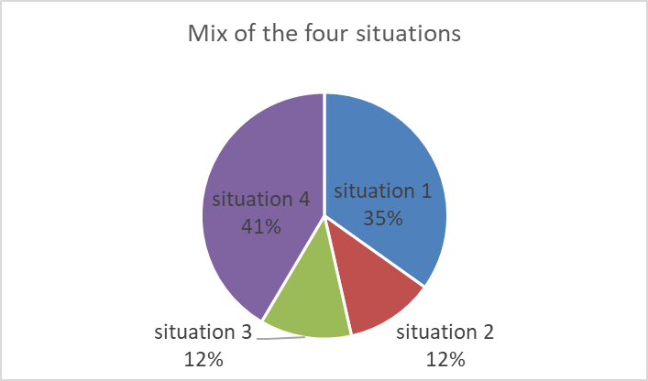



The number of up-day-one is about 1.5 times of down-day-1. In up-day-one situations, we mainly care about situation1. It has the largest share, about 60% in all the up-day-one situations.

**Analysis on Trough date /Peak date**

The distribution of trough date and peak date is as shown in the below figures:

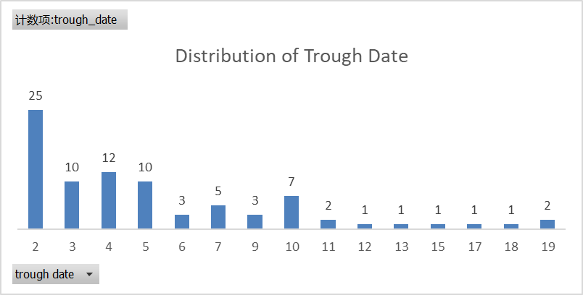

From this figure, the trough is likely to happen on day 2,3,4,5, taking the share of 67.9% in situation1. The average of trough date is 5.5 and the median is 4. Trough date on day 2 means that the price drops below day1 on day2 and before it rebounds above day1 price, the lowest price it could reach is on day 2.

The mix of retrace date = trough date is shown below:



This indicates that for 60% percent of situation1, the stock reaches it’s lowest price as soon as it drops below day1 price.

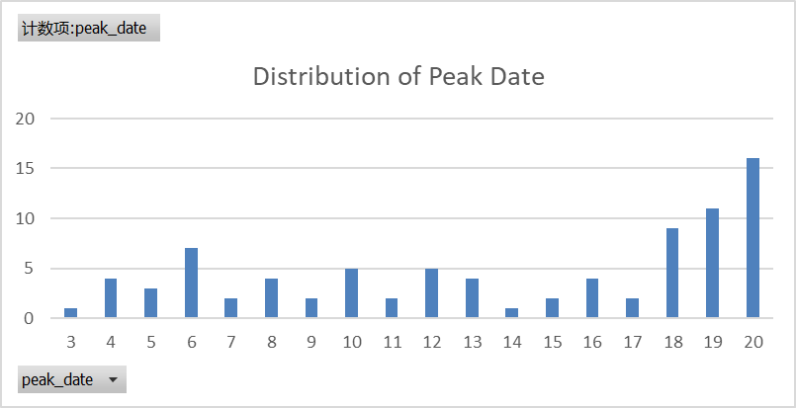

The average of Peak date is 13.78. The peak after rebound is likely to be on day18, 19, 20, indicating that the trend of increasing may not end. In this case, an investigation was conducted and 7 out of 36 (20%) samples get their “actual peak” on day 18,19,20 within two earnings.



According to this table, 78.6% of the peaks actually happens outside of the 20-days window.

The average of the trough loss is -2.9% and the average of the peak gain is 6.4%.

**Analysis on Trough Loss/Peak Gain**

The distribution of Peak gain and trough loss is shown below:

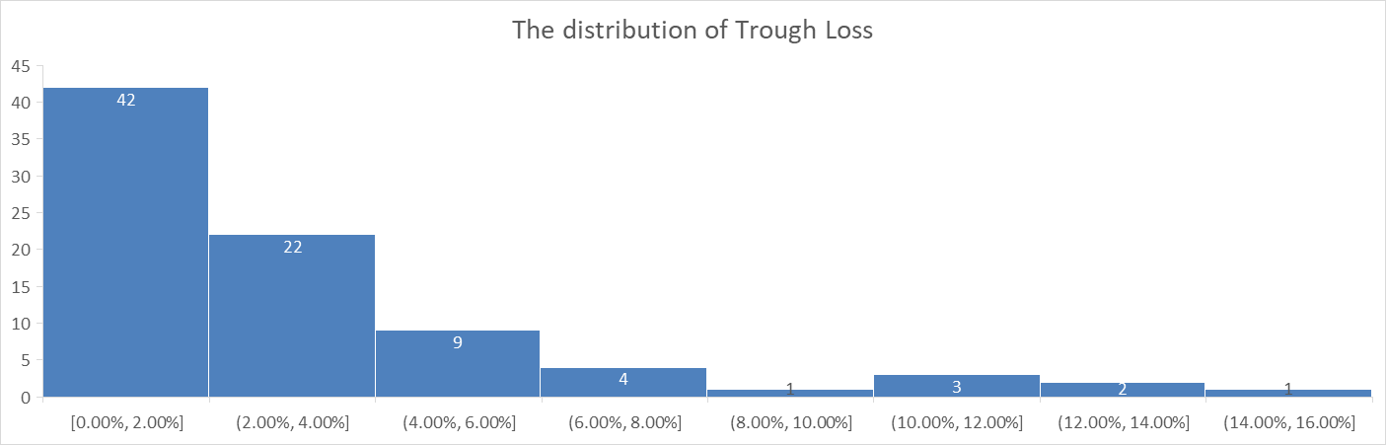

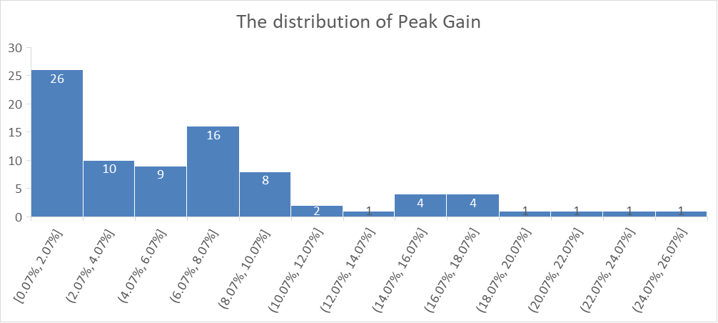

1. From these figures, we can see that Peak gain mainly lies in 0% - 2.0% and 6%-8%, while trough loss mainly lies in 0% to -2% and -2% to -4%.

**Analysis on samples whose Trough date is 2,3,4,5**

The number of these samples is 67.9% of all situation1 samples. The average of trough loss and peak gain is -2.6% and 6.8%. I also draw the distribution of Peak – trough (how long it takes to rebound to maximum price after the trough) as shown below:

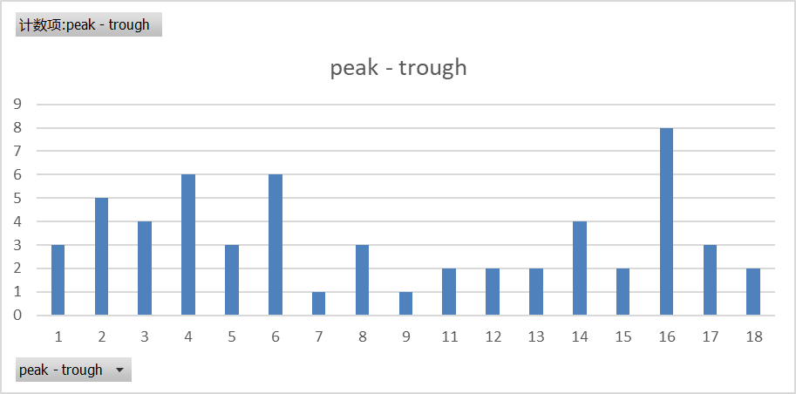

The distribution shows that usually it takes 2-6 days to rebound or 16 days. The average of Peak-trough is 9.

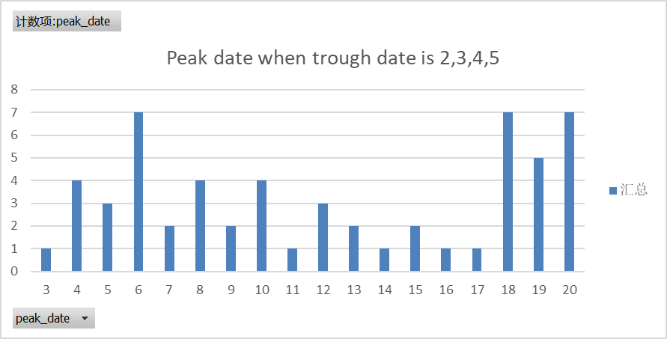

From this figure it could be discovered that when trough date is on 2,3,4,5, the peak date is likely to be on the 6th day or day 18. 19, 20, indicating that if the increasing trend does not stop on day 6, it will continue to increase until at least 18, 19, 20 days